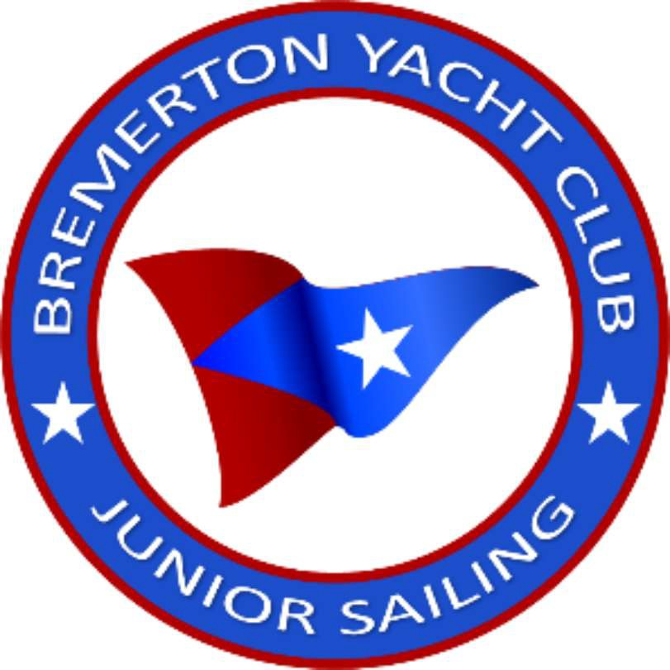BYC Junior Sail Cancellation Policy

Registration fees are essential for us to pay our staff and expenses. Non­ refundable charges include the Sports Connect Service Fee paid by campers, as well as credit card fees (3.99%) charged by Sports Connect for each transaction.

Our normal cancellation policy will be in effect for circumstances unrelated to COVID-19. If registration is canceled:

**At least 30-days prior to the start of camp:**

* Canceled - 100% refund of their BYC Junior Sail Camp registration fees.
* Rescheduled or funds held for future programs (within 18 months) - no cancellation fees

**Between 15 and 30-days prior to the start of camp:**

* Canceled - if we are able to fill the space at camp, 100% refund of their BYC Junior Sail Camp. If we are unable to fill the space, campers will be given a 50% refund of their BYC Camp registration fee.

**Within 14-days of camp:**

* Canceled - if we are able to fill the space at camp, 100% refund of their BYC Junior Sail Camp.

**No refunds if the space cannot be filled.**